Cloud Developer, Cloud DevOps Engineer

Storage, Serverless

**Lab Steps**

Task 1: Sign in to AWS Management Console

1. Click on the  button, and you will get redirected to AWS Console in a new browser tab.
2. On the AWS sign-in page,
   * Leave the Account ID as default. Never edit/remove the 12 digit Account ID present in the AWS Console. otherwise, you cannot proceed with the lab.
   * Now copy your **User Name** and **Password** in the Lab Console to the **IAM Username and Password** in AWS Console and click on the **Sign in** button.
3. Once Signed In to the AWS Management Console, Make the default AWS Region as **US East (N. Virginia) us-east-1.**

Task 2: Create a SQS Queue

1. Navigate to the **Services** menu on the top, select **Simple Queue Service** under **Application Integration**.
2. Make sure you are in the **N. Virginia**region.
3. Click on the **Create queue** button.

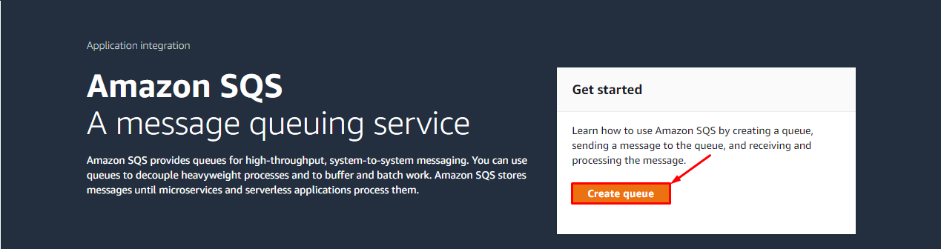

1. **Details :**
   * Type : Select **Standard**
   * Name : Enter ***Whizlabs-sqs***

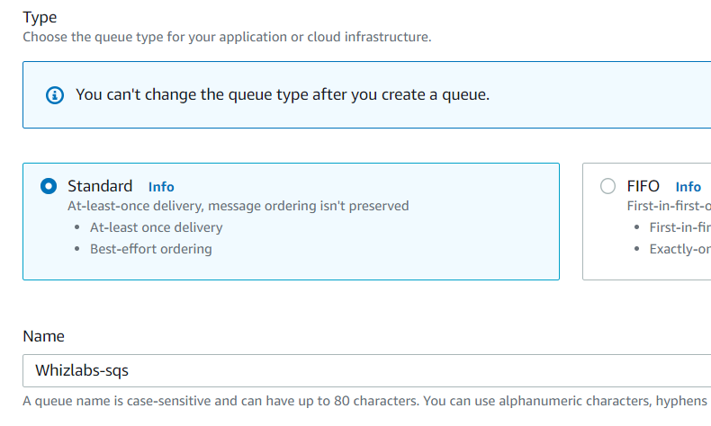

1. **Configuration :**
   * Visibility timeout : Enter ***1*** Minute
   * Leave everything as default.

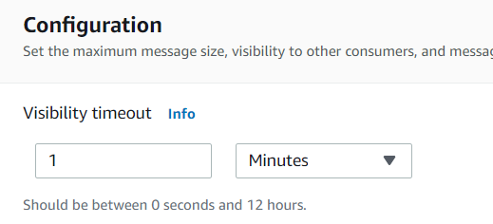

1. Click on the **Create queue** button.

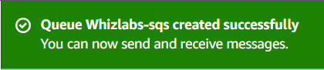

1. Now copy the Queue **URL** under **Details** and place it in the text editor, we will be using this while creating the lambda function.  
   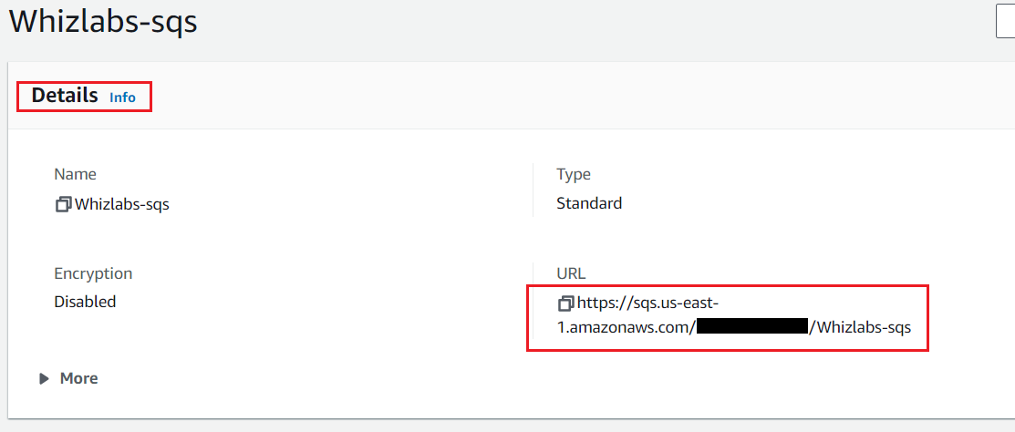

Task 3: Create a lambda function

1. Click on the link <https://console.aws.amazon.com/lambda/home?region=us-east-1#/functions> to open Lambda console in a new tab in the browser. **It is important to have both SQS and Lambda functions opened in two tabs**.
2. Make sure you are in the **US East (N. Virginia)** region.
3. Click on the 
   * Choose .
   * Function name : Enter ***my_sqs_Lambda***
   * Runtime: Select ***Python 3.8***
   * Permissions: Click on the  **Change default execution role** and choose 
   * **Existing role:** Select **task165_role_<RANDOM_NUMBER>**from the dropdown list.
   * Click on **Create function** button.

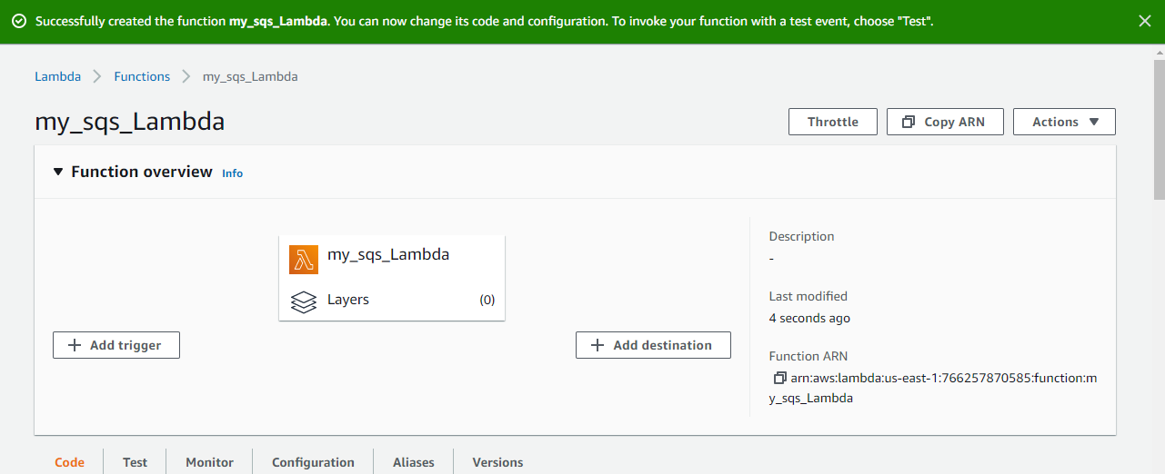

1. **Code**section, Replace the existing code with the below

|  |
| --- |
| import json  import boto3  def lambda_handler(event, context):  try:  sqsClient = boto3.client("sqs", region_name="us-east-1")  try:  response = sqsClient.receive_message(  QueueUrl="<your Queue URL>",  AttributeNames=['All'],  )  print(response)  return response  except Exception as e:  print("Get queue message failed because ", e)  except Exception as e:  print("Client connection to SQS failed because ", e) |

1. **Note:**Pleasepaste the SQS Queue URL which you copied and placed in the text editor.

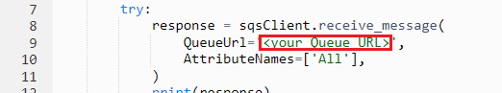

1. Save the function by clicking on **Deploy**in the-top right corner.
2. Now click on **Test** button, Event name : Enter ***LambdaTest***and click on the **Save**button.

Task 4: Send a message with Visibility Timeout

1. Go to the SQS Queue browser tab.
2. Click on the **Send and recieve messages** button on the top right side.
3. Under **Send message:**
   * Message body : Enter ***Test Visibility timeout***
4. Now click on the **Send message**button.
5. You will be able to see a similar message.

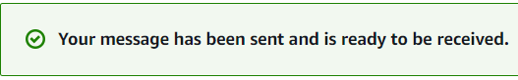

1. Now go to the Lambda function Browser tab.
2. Click on **Test** button of your function and check the lambda function execution output.
3. You will be able to see the message that you have sent in the Queue, as shown below.

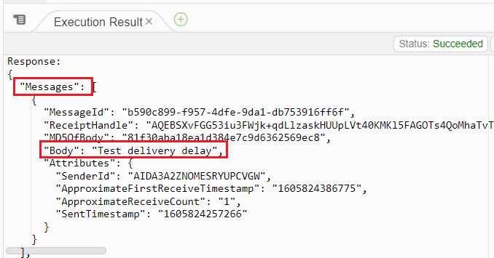

1. Now again click on the **Test** button and check the lambda output.
2. **You won't be able to see the message, this is because once the message is received by the lambda function (Consumer). The visibility timeout starts, which you have set to 1 Minute.**

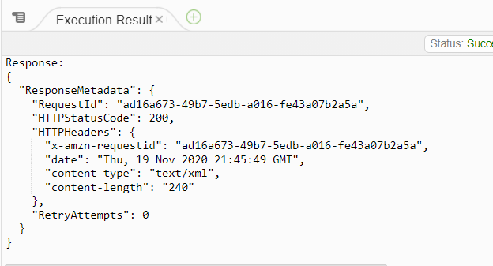

1. For 1 Minute the message will not be available in the queue to be received by the consumer. This is what visibility timeout is set.
2. Try to **Test** the lambda function after **1 Minute** and you will be able to receive the message again.

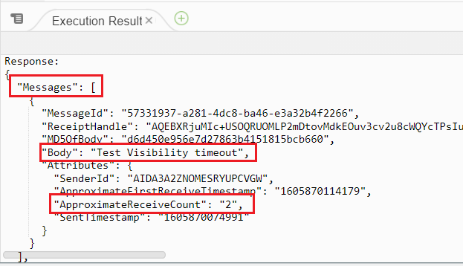

Task 5: Purge the Queue

1. Navigate to the SQS browser tab.
2. Click on the queue name on top left of the page.



1. Now click on **Purge** button.
2. Enter ***purge*** in the confirm box and click on **Purge** button.
3. Purge will delete all the messages present in the queue.

Task 6: Send a message with Delivery Delay

1. Click on the **Send and recieve messages** button on the top right side.
2. Under **Send message:**
   * Message body : Enter ***Test delivery delay***
   * Delivery Delay : Enter ***30*** Seconds

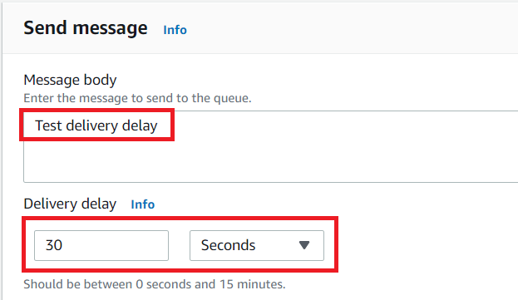

1. Now click on the **Send message** button.
2. You will be able to see a similar message.

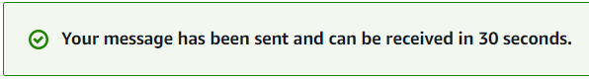

1. Now go to the Lambda function Browser tab.
2. Click on **Test** button of your function and check the lambda function execution output.

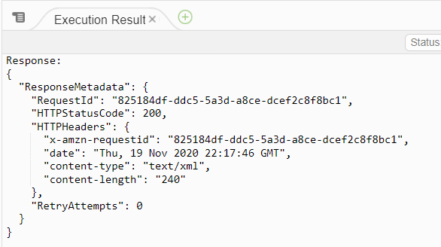

1. The message is not available, because we have added a delay to deliver the message to the consumer (Lambda function)
2. Now **wait for 30 seconds** and then again click on **Test** button of your function and check the lambda function execution output.



Task 7: Purge the Queue

1. Navigate to the SQS browser tab.
2. Click on the queue name on top left of the page.



1. Now click on **Purge** button.
2. Enter ***purge*** in the confirm box and click on **Purge** button.

Task 8: Delete AWS Resources

**Delete SQS Queue**

1. Navigate to the **Services** menu on the top, select **Simple Queue Service**under **Application Integration**.
2. Make sure you are in the **N. Virginia**region.
3. In the left top side click on  and then click on **Queues**.
4. Select your SQS Queue Whizlabs-sqs and click on the **Delete** button.

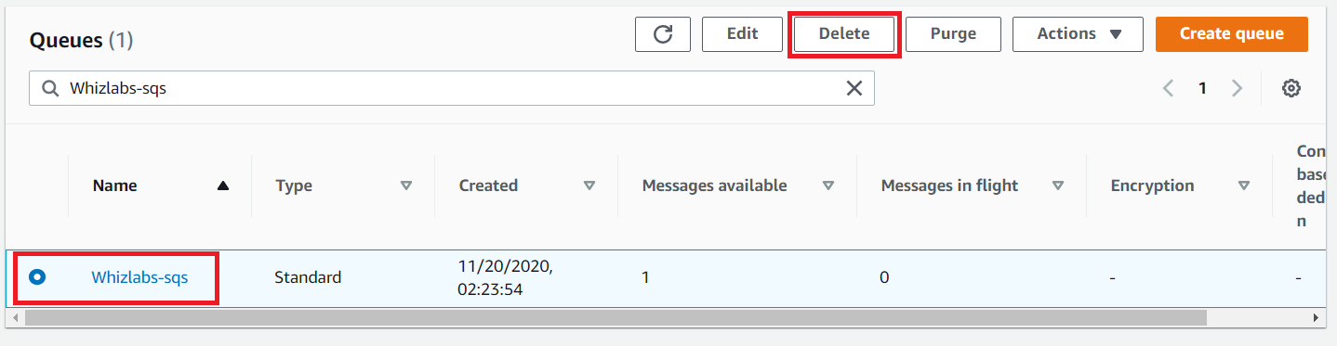

1. Enter ***delete*** in the confirm box and click on **Delete** button.

**Delete Lambda Function**

1. Navigate to **Lambda** by clicking on the **Services** menu at the top, then click on **Lambda** in the **Compute** section.
2. Make sure you are in the **US East (N. Virginia)** region.
3. Select the lambda function my_sqs_Lambda and click **Actions** and click  button.

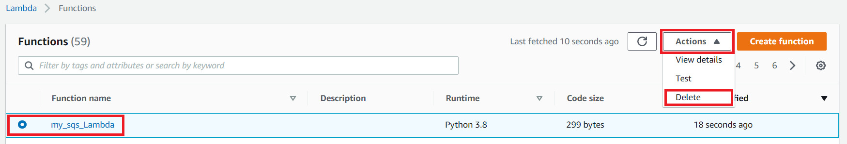

1. Click the **Delete** button to confirm deletion.

**Completion and Conclusion**

1. You have successfully created a SQS queue.
2. You have successfully created a Lambda function.
3. You have successfully sent a message with Visibility Timeout.
4. You have successfully purged the Queue.
5. You have successfully sent a message with Delivery Delay.
6. You have successfully purged the Queue.

**End Lab**

1. Sign out of the AWS Account.
2. You have successfully completed the lab.